10G SFP+ Active Optical cable

Features：
- Support 10GBASE-SR/10G Fiber Channel application
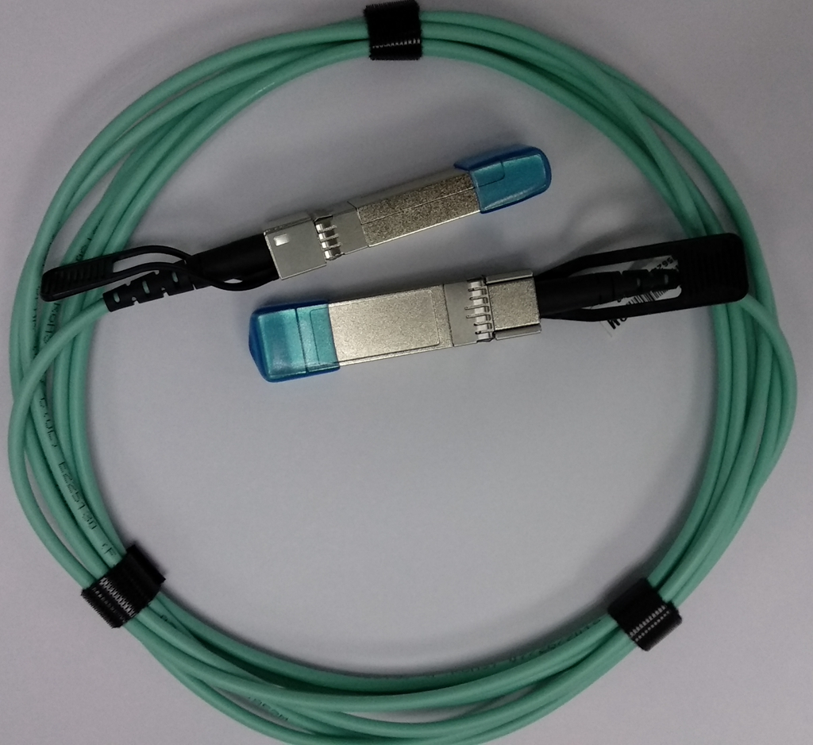
- Compliant to SFP+ Electrical MSA SFF-8431
- Compliant to SFP+ Mechanical MSA SFF-8432
- Multi rate of up to 11.3Gbps
- Transmission distance up to 300m
● +3.3V single power supply
- Low power consumption
- Operating case temp Commercial: 0°C to +70 °C
- RoHS compliant
- Password protection for A0h and A2h

Applications
- 10GBASE-SR at 10.31Gbps
- InfiniBand QDR, SDR, DDR
- Other optical links

Absolute Maximum Ratings
Table1- Absolute Maximum Ratings
Parameter | Symbol | Min. | Typical | Max. | Unit | Notes
Supply Voltage | Vcc₃ | -0.5 | - | +3.6 | V
Storage Temperature | T_{s} | -10 | - | +70 | °C
Operating Humidity | RH | +5 | - | +85 | % | 1
Receiver Damage Threshold | P Rdmg | +3.4 | - | - | dBm
Note1: No condensation
Recommended Operating Conditions
Table 2- Recommended operating Conditions
Parameter | Symbol | Min. | Typical | Max. | Unit | Notes
Operating Case Temperature | T_{C} | 0 | - | +70 | °C
Power Supply Voltage | Vcc | 3.14 | 3.3 | 3.47 | V
Power Supply Current | Icc | - | - | 150 | mA
Power Dissipation | Pd | - | - | 0.6 | W
Bit Rate | BR | - | 10.3125 | - | Gbps
Fiber Bend Radius | Rb | 3 | - | - | cm

Electrical Characteristics
Table 3- Electrical Characteristics
Parameter |  |  | Symbol |  | Min. | Typ. | Max. | Units |  | Notes
Transmitter
Differential Data Input Swing |  |  | Vin,P-P |  | 200 | - | 1600 |  | mV_{PP}
Input Differential Impedance |  |  | ZIN |  | 90 | 100 | 110 |  | Ω
Tx_Fault | Normal Operation |  | VOL |  | 0 | - | 0.8 |  | V
Tx_Fault | Transmitter Fault |  | VOH |  | 2.0 | - | VCC |  | V
Tx_Disable | Normal Operation |  | VIL |  | 0 | - | 0.8 |  | V
Tx_Disable | Laser Disable |  | VIH |  | 2.0 | - | V_{CC}+0.3 |  | V
Receiver
Differential Date Output |  |  |  | Vout | 370 | - | 1600 | mV
Output Differential Impedance |  |  |  | Z_{D} | 90 | 100 | 110 | Ω
Rx_LOS |  | Normal Operation |  | VOL | 0 | - | 0.8 | V
 |  | Lose Signal |  | VoH | 2.0 | - | VCC | V

Optical Characteristics
Table 4-Optical Characteristics
Parameter | Symbol | Unit | Min | Typ | Max | Notes
Optical transmitter Characteristics
Data Rate | DR | Gbps | 9.953 | 10.3125 | 11.3
Center Wavelength Range | λc | nm | 820 | 850 | 880
Laser Off Power | Poff | dBm | - | - | -45
Launch Optical Power | P0 | dBm | -6.0 | - | - | 1
Extinction Ratio | ER | dB | 3 | - | -
Spectral Width(RMS) | RMS | nm | - | - | 0.45
Optical Receiver Characteristics
Data Rate | DR | Gbps | 9.953 | 10.3125 | 11.3
Bit Error Rate | BER | dBm | - | - | E-12 | 2
Overload Input Optical | PIN | dBm | 2.4 | - | - | 2

Power
Center Wavelength Range | λc | nm | 820 | - | 880
Receiver Sensitivity in  Average Power | Sen | dBm | - | - | -9.9 | 3
Los Assert | LosA | dBm | -26 | - | -
Los De-Assert | LosD | dBm | - | - | -12
Los Hysteresis | LosH | dB | 0.5 | - | -
Note:
- Coupled into 50/125 MMF.
- Measured with PRBS 2³¹-1 test pattern @10.3125Gbps.BER=10E-12

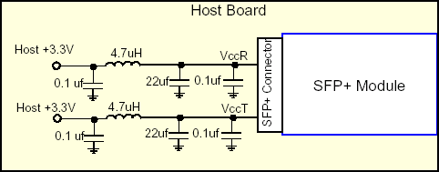
Recommended Host Board Power Supply Circuit
Figure 1, Recommended Host Board Power Supply Circuit

Recommended Interface Circuit
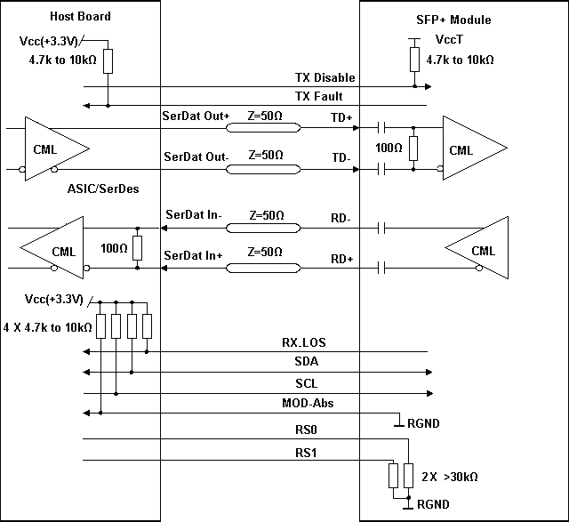
Figure 2, Recommended Interface Circuit
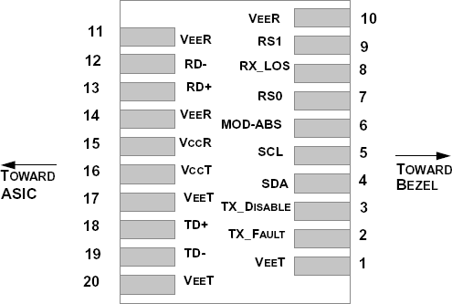
Pin arrangement

Table 5-Pin Function Definitions
Figure 3, Pin View

Pin | Symbol | Name/Description | Notes
1 | VEET | Module Transmitter Ground | 1
2 | TX_FAULT | Module Transmitter Fault | 2
3 | TX_DISABLE | Transmitter Disable; Turns off transmitter laser output | 3
4 | SDA | 2-Wire Serial Interface Data Line (MOD-DEF2)
5 | SCL | 2-Wire Serial Interface Clock (MOD-DEF1)
6 | MOD_ABS | Module Absent, connected to V_{EE}T or V_{EE}R in the module | 2
7 | RS0 | Rate Select 0, optionally controls SFP+ module receiver
8 | RX_LOS | Receiver Loss of Signal Indication (In FC designated as Rx_LOS and in Ethernet designated as NOT Signal Detect) | 2
9 | RS1 | Rate Select 1, optionally controls SFP+ module transmitter
10 | V_{EE}R | Module Receiver Ground | 1
11 | V_{EE}R | Module Receiver Ground | 1
12 | RD- | Receiver Inverted Data Output
13 | RD+ | Receiver Non-Inverted Data Output
14 | V_{EE}R | Module Receiver Ground | 1
15 | V_{CC}R | Module Receiver 3.3 V Supply
16 | V_{CC}T | Module Transmitter 3.3 V Supply
17 | V_{EE}T | Module Transmitter Ground | 1
18 | TD+ | Transmitter Non-Inverted Data Input
19 | TD- | Transmitter Inverted Data Input
20 | V_{EE}T | Module Transmitter Ground | 1
Note:
- The module ground pins are isolated from the module case.
- The pins shall be pulled up with 4.7K-10Kohms to a voltage between 3.14V and 3.46V on host board.
- The pin is pulled up to VCCT with a 4.7K-10KΩ resistor in the module.

Monitoring Specification
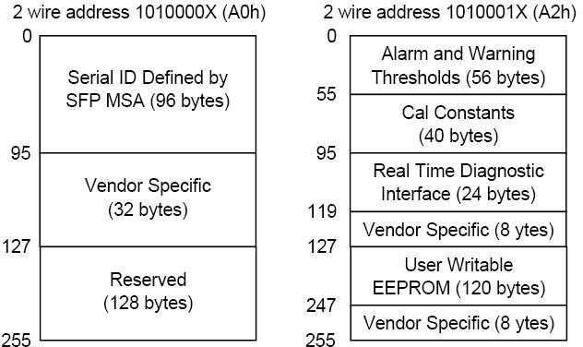

Figure 4, Memory Map

Mechanical Design Diagram
Unit:mm

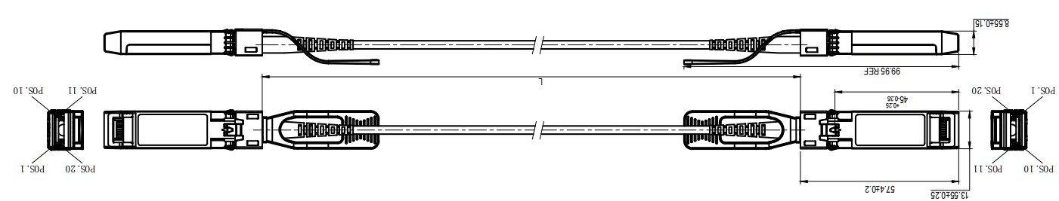

Cable Length L（Unit: m） | Tolerant（Unit: cm）
≤1.0 | +5/-0
1.0＜L≤4.5 | +15/-0
4.5＜L≤14.5 | +30/-0
＞14.5 | +2%/-0
Table 6- Cable Length

Warnings
Handling Precautions: This device is susceptible to damage as a result of electrostatic discharge (ESD).
A static free environment is highly recommended. Follow guidelines according to proper ESD procedures.
Laser Safety: Radiation emitted by laser devices can be dangerous to human eyes. Avoid eye exposure to direct or indirect radiation.

